**Web Design and Development Foundations with HTML5**

**Hands-On Practice (HOP)**

HOP 14.1

The working alert

The Console

HOP 14.2

HOP 14.3

Mouseover alert

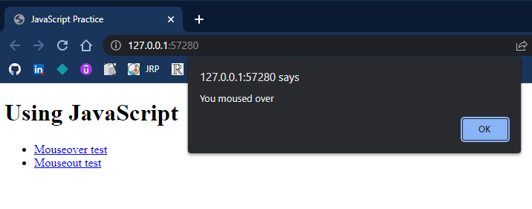

Mouseout alert

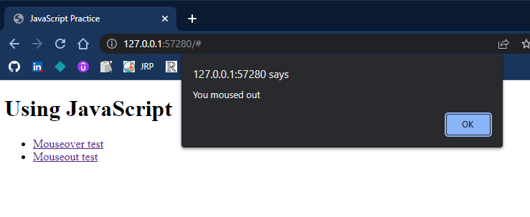

HOP 14.4

HOP 14.5

* var3.html
* Prompt to enter your name

* Output after the prompt

* var4.html
* The prompt with blue chosen

* The output with blue

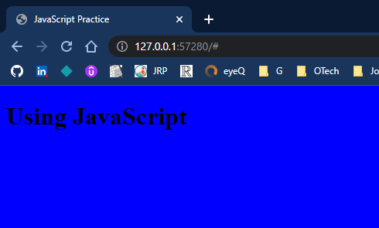

* The output with red

HOP 14.6

The prompt with a number less than 0

The output when less than 0

The prompt with a number greater than 0

The output when greater than 0

HOP 14.7

Prompt box

Output when number is greater than 0

Output when number is less than 0

HOP 14.8

Form

Prompt when name field is empty

Prompt when age is less than 18

Prompt when name and age are valid

Output "Your information has been received" with the information that you typed into the form

HOP 14.9

HOP 14.10

Page before clicking "More"

Page after clicking "More"

HOP 14.11

HOP 14.12

HOP 14.13

Form

Form showing that the Name and E-Mail fields are required

Form with an invalid email address

Output "Your information has been received" including information typed into the form